www.returnoftheremnant.com
Shabbat Services
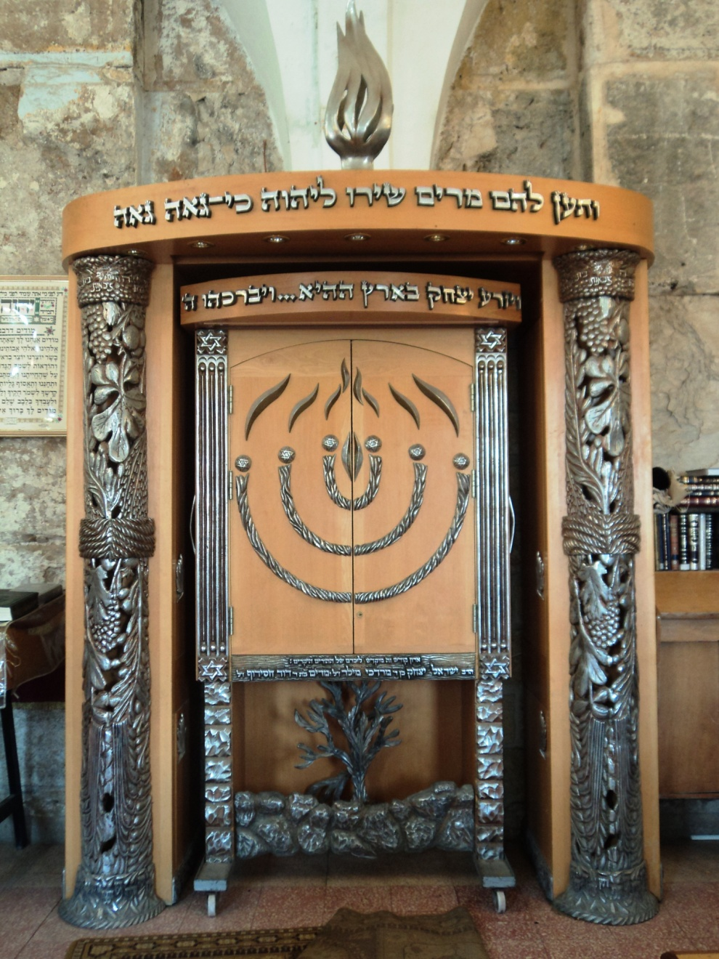Return of the Remnant Ministries

