Rosh Chodesh
~Celebrating the New (Renewed) Month~

1.) Leader recites: It is noteworthy that Rosh Chodesh was the first commandment given to Israel as a nation. The Book of Exodus recounts the beginning of the Hebrew Calendar: “And YHWH spoke to Moses and Aaron in the land of Egypt, saying: ‘This month shall mark for you the beginning of months; it shall be the first of the months of the year for you.’” (Exodus 12:1-2) The observance of Rosh Chodesh is important in understanding the correct dates of the Feast Days of YHWH as defined in Leviticus 23.
2.) Leader continues: In the Book of Numbers, Elohim speaks of the celebration of the new moon to Moses: “Also in the day of your gladness, and in your solemn days, and in the beginnings of your months, you shall blow with the trumpets over your burnt offerings, and over the sacrifices of your peace offerings; that they may be to you for a memorial before your Elohim: I am YHWH your Elohim.” (Numbers 10:10). Elohim also says: ”For as the new heavens and the new earth, which I will make, shall remain before me, says YHWH, so shall your seed and your name remain. And it shall come to pass, that from one new moon to another, and from one Sabbath to another, shall all flesh come to worship before me, says YHWH.” (Isaiah 66:22-23)
View the New Moon
Leader assembles everyone to view the New Moon if possible. If the New Moon is visible (look to the Western Sky for the sliver of the moon), the blessing below may be recited together while viewing it. (Have Shofars handy!)

3.) Everyone recite together: Blessed are you, YHWH our Elohim, King of the universe, who has given the days of Rosh Chodesh to His people Israel for remembrance. May it be Your will, YHWH our Elohim and Elohim of our fathers, that You renew for us a good month. In the name of Messiah Yahshua, Amen.
Designate readers to read aloud: Psalm 121, 150, 67, Jeremiah 31:31-36

4.) Leader recites: The following verse in the Book of Psalms says that blowing the trumpet (shofar) is an ordinance. “Blow the shofar on Rosh Chodesh, in the time appointed on our solemn feast days. For this is a statute for Israel, a ruling of the Elohim of Jacob. (Psalm 81:3-4)

**ALL BLOW SHOFAR(S)**

5.) Everyone recite together: (Psalm 146:1-6)
HalleluYAH! Praise YHWH from the heavens; praise Him in the heights, Praise Him, all His angels; praise Him, all His legions. Praise Him, sun and moon; Praise Him, all you stars of light. Praise Him, the most exalted of the heavens and the waters that are above the heavens. Let them praise the name of YHWH, for He commanded and they were created. And He established them forever and ever, a decree He issued that will not change.

~Birkhhat HaChodesh (Sanctification of the Month)~

6.) Everyone recite together: May it be Your will, YHWH our Elohim and the Elohim of our fathers, that You begin for us this month for good and for blessing. May You give to us long life, a life of peace, a life of goodness, a life of blessing, a life of sustenance, a life of spiritual, mental, and physical health, a life in which there is fear of heaven and fear of sin, a life in which we love YHWH and His Word (Torah); a life in which YHWH fulfills the requests of our hearts for good. Amen

7.) Leader recites: YHWH, the One who performed miracles for our forefathers and redeemed them from slavery to freedom, may He redeem us soon and gather in all of His people Israel from the four corners of the earth… And let us all say…Amen.
May the Holy One, Blessed is He, renew it upon us and upon all His people, the whole house of Israel, for goodness and blessing, for joy and gladness, for redemption and consolation, for sustenance and support, for good life and peace, for rains in their proper time, for complete recovery, and for salvation and restoration…And let us all say…Amen.

8.) Worship song: (Pick a song for all to sing together)
(example)- I want to see Israel marching, I want to hear that shofar call, I want to climb Zion’s mountain, I want to see the great Babylon fall, I want to see Yahshua reigning on King David’s Royal throne, won’t that be a glorious site to see, when Israel comes marching home!

9.) Leader recites: May YHWH our Elohim grant that this new month bring to us and to all His people, the whole house of Israel, life and peace, joy and gladness, salvation and comfort…

Pause to allow people to: (any of the following)
*Express publicly what you have to praise YHWH about.
*Acknowledge to YHWH what he has done for you during the past month
*Add their personal wishes for the upcoming month

When everyone is done, leader to conclude:
And let us say, amen.

10.) Scripture readings related to the moon:
Psalm 136:4-9. Psalm 104:19-24. Psalm 89:31-37: “If they break my statutes,
and keep not my commandments; Then will I visit their transgression with the
rod, and their iniquity with stripes. Nevertheless my lovingkindness will I not
utterly take from him, nor suffer my faithfulness to fail. My covenant will I not
break, nor alter the thing that is gone out of my lips. Once have I sworn by my
holiness that I will not lie unto David. His seed shall endure forever, and his
throne as the sun before me. It shall be established forever as the moon, and
as a faithful witness in heaven.” Selah.

11.) The New Moon was celebrated… During the days of King Saul, the king held a special meal for his guests on Rosh Chodesh: David was invited to sit at the King’s table but King Saul was seeking to take David’s life. 1 Samuel 20:5,18 it is written “And David said unto Jonathan, Behold, tomorrow is the new moon, and I should not fail to sit with the king at meat: but let me go, that I may hide myself in the field unto the third day at evening… Jonathan said to David …Tomorrow will be the new moon; and you will be missed because your seat will be empty.”
…and the New Moon Observance should continue to be kept: Colossians 2:16-17 “Let no man therefore judge you in meat, or in drink, or in respect of an holyday, or of the new moon, or of the Sabbath days: Which are a shadow of things to come; but the body is of Messiah.
(OPTIONAL: Traditional blessings over wine and bread)

Closing Salutation

12.) Everyone recite together:
“Chodesh Tov! A good month, a month of health, fulfillment and peace.” Amen

Works cited: The New Moon: Celebrating His Blessings – Mike Clayton, Artscroll Siddur – Rabbi Scherman, Various Internet information and sources
Artwork: Front Cover: www.oztorah.com, Back Cover: www.free-bitsela.com
Developed by: www.returnoftheremant.com

Berachot Rosh Chodesh
“Blessings for the new (renewed) month”

vdwx var
Rosh Chodesh

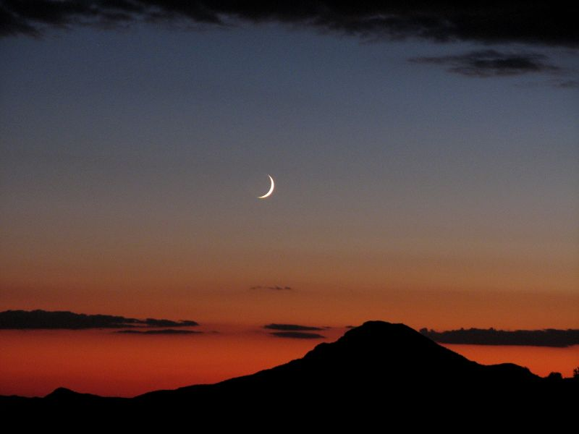

“He (YHWH) made the moon to mark the seasons…”
(Psalms 104:19)

