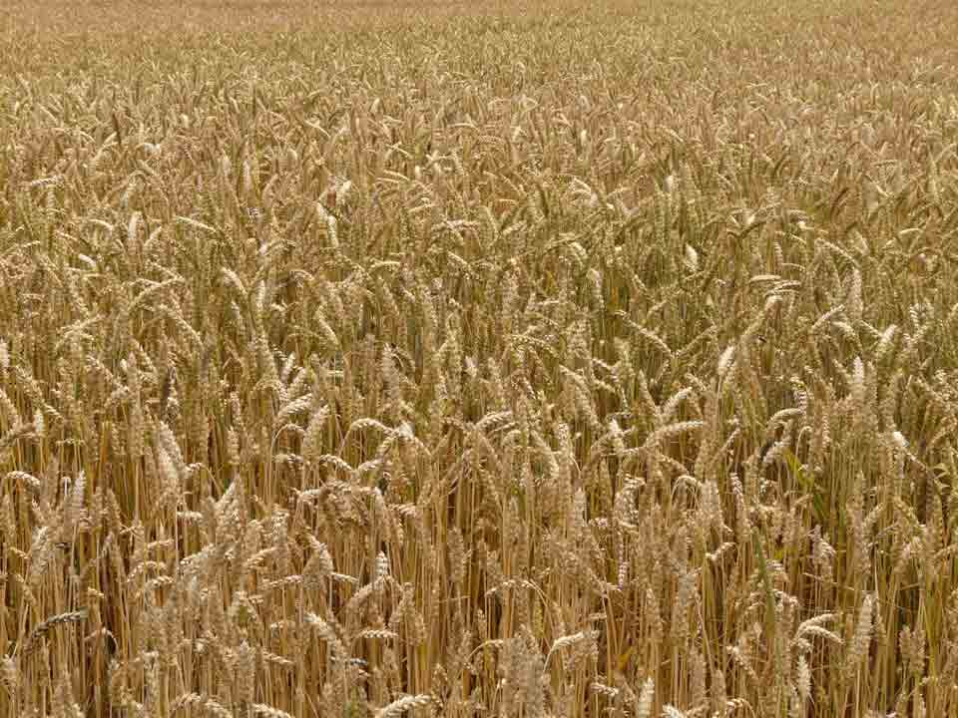
Counting of the Omer 2015
ספירת
העומר

Lev 23:15-16 ‘And from the morrow after the Sabbath, from the day that you brought the sheaf of the wave offering, you shall count for yourselves: seven completed Sabbaths. ‘Until the morrow after the seventh Sabbath you count fifty days, then you shall bring a new grain offering to יהוה.
We are instructed by יהוה to count 49 days (7 completed Sabbaths) concluding with the celebration of Shavuot on the 50th day. This period is called "Sefirat HaOmer", the counting of the Omer. According to Rabbinic sources, the Omer count recalls an earlier event when the children of Israel prepared themselves for receiving the Torah at Mt. Sinai at Shavuot. It is also important to note that on Shavuot ("Pentecost" in Greek) the disciples of Yahshua were filled with the "Spirit of Elohim" (Acts 2). May you draw near to HIM and be filled with the spirit of wisdom and truth during these 50 days.

Day 1 [Sunday following the regular Shabbat during unleavened bread]
€ Hoshea 1-2

Day 2 - April 6th
€ Hoshea 3

Day 3
€ Hoshea 4

Day 4
€ Hoshea 5

Day 5
€ Hoshea 6

Day 6
€ Hoshea 7

Day 7 Shabbat ~ First Completed Week ~ April 11th
€ Hoshea 8

Day 8
€ Hoshea 9

Day 9
€ Hoshea 10

Day 10
€ Hoshea 11

Day 11
€ Hoshea 12

Day 12
€ Hoshea 13-14

Day 13
€ Joel 1-2

Day 14 Shabbat ~ Second Completed Week ~ April 18th
€ Joel 3-4

Day 15
€ Amos 1

Day 16
€ Amos 2

Day 17
€ Amos 3-4

Day 18
€ Amos 5

Day 19
€ Amos 6-7

Day 20
€ Amos 8-9

Day 21 Shabbat ~ Third Completed Week ~ April 25th
€ Ovadyah

Day 22
€ Michoh 1-2

Day 23
€ Michoh 3

Day 24
€ Michoh 4

Day 25
€ Michoh 5

Day 26
€ Michoh 6

Day 27
€ Michoh 7

Day 28 Shabbat ~ Fourth Completed Week ~ May 2nd
€ Nachum 1

Day 29
€ Nachum 2-3

Day 30
€ Chabakuk 1

Day 31
€ Chabakuk 2

Day 32
€ Chabakuk 3

Day 33 – Lag B’Omer
€ Tzefanyah 1

Day 34
€ Tzephanyah 2

Day 35 Shabbat ~ Fifth Completed Week ~ May 9th
€ Tzephanyah 3

Day 36
€ Chaggai 1-2

Day 37
€ Zecharyah 1-2

Day 38
€ Zecharyah 3-4

Day 39
€ Zecharyah 5-6

Day 40
€ Zecharyah 7

Day 41
€ Zecharyah 8

Day 42 Shabbat ~ Sixth Completed Week ~ May 16th
€ Zecharyah 9

Day 43
€ Zecharyah 10

Day 44
€ Zecharyah 11

Day 45
€ Zecharyah 12

Day 46
€ Zecharyah 13

Day 47
€ Zecharyah 14

Day 48
€ Mal’akhi 1-2

Day 49 Shabbat ~ Seventh Completed Week ~ May 23rd
€ Mal’akhi 3-4

Day 50 ~ SHAVUOT! ~ (Yom HaBikurim) – May 24^{h}
€ Megilath Ruth

Additional readings on Shavuot:
Acts 2:1 - 47 Numbers 28:26 - 31
Exodus 19:3 - 20:26 Deuteronomy 14:22 - 16:17
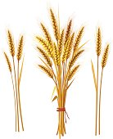
Leviticus 23:15 – 21
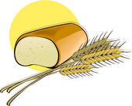

Other dates to remember during the counting of the Omer:

April 16th Holocaust Memorial day (Yom Hashoah)
April 22nd Memorial Day (Yom Hazikaron)
April 23rd Israel Independence Day (Yom Ha'Atzmaut)
May 17th Jerusalem Day (Yom Yerushalayim)
May 18th Hebron (Liberation) Day (Yom Hebron)

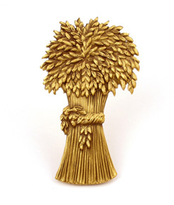
For Further information, go to:
www.returnoftheremnant.com

