Counting of the Omer 2013
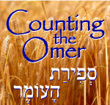

Lev 23:15-16 ‘And from the morrow after the Sabbath, from the day that you brought the sheaf of the wave offering, you shall count for yourselves: seven completed Sabbaths. ‘Until the morrow after the seventh Sabbath you count fifty days, then you shall bring a new grain offering to יהוה.
We are instructed by יהוה to count 49 days (7 completed Sabbaths) concluding with the celebration of Shavuot on the 50th day. This period is called "Sefirat HaOmer", the counting of the Omer. According to Rabbinic sources, the Omer count recalls an earlier event when the children of Israel prepared themselves for receiving the Torah at Mt. Sinai at Shavuot. It is also important to note that on Shavuot ("Pentecost" in Greek) the disciples of Yahshua were filled with the "Spirit of Elohim" (Acts 2). May you draw near to HIM and be filled with the spirit of wisdom and truth during these 50 days.

Day 1 [Sunday following the regular Shabbat during unleavened bread]
€Yermiyahu 1

Day 2 - April 1st
€ Yermiyahu 2

Day 3
€ Yermiyahu 3

Day 4
€ Yermiyahu 4

Day 5
€ Yermiyahu 5

Day 6
€ Yermiyahu 6

Day 7 Shabbat ~ First Completed Week ~ April 6th
€ Yermiyahu 7

Day 8
€ Yermiyahu 8

Day 9
€ Yermiyahu 9

Day 10
€ Yermiyahu 10

Day 11
€ Yermiyahu 11

Day 12
€ Yermiyahu 12

Day 13
€ Yermiyahu 13

Day 14 Shabbat ~ Second Completed Week ~ April 13th
€ Yermiyahu 14

Day 15
€ Yermiyahu 15

Day 16
€ Yermiyahu 16

Day 17
€ Yermiyahu 17

Day 18
€ Yermiyahu 18

Day 19
€ Yermiyahu 19

Day 20
€ Yermiyahu 20

Day 21 Shabbat ~ Third Completed Week ~ April 20th
€ Yermiyahu 21

Day 22
€ Yermiyahu 22

Day 23
€ Yermiyahu 23

Day 24
€ Yermiyahu 24

Day 25
€ Yermiyahu 25

Day 26
€ Yermiyahu 26

Day 27
€ Yermiyahu 27

Day 28 Shabbat ~ Fourth Completed Week ~ April 27th
€ Yermiyahu 28

Day 29
€ Yermiyahu 29

Day 30
€ Yermiyahu 30

Day 31
€ Yermiyahu 31

Day 32
€ Yermiyahu 32

Day 33 – Lag B’Omer
€ Yermiyahu 33

Day 34
€ Yermiyahu 34

Day 35 Shabbat ~ Fifth Completed Week ~ May 4th
€ Yermiyahu 35

Day 36
€ Yermiyahu 36

Day 37
€ Yermiyahu 37

Day 38
€ Yermiyahu 38

Day 39
€ Yermiyahu 39

Day 40
€ Yermiyahu 40

Day 41
€ Yermiyahu 41

Day 42 Shabbat ~ Sixth Completed Week ~ May 11th
€ Yermiyahu 42

Day 43
€ Yermiyahu 43

Day 44
€ Yermiyahu 44

Day 45
€ Yermiyahu 45

Day 46
€ Yermiyahu 46

Day 47
€ Yermiyahu 47, 48

Day 48
€ Yermiyahu 49,50

Day 49 Shabbat ~ Seventh Completed Week ~ May 18th
€ Yermiyahu 51,52

Day 50 ~ SHAVUOT! ~ (Yom HaBikurim) – May 19th
€ Scroll of Ruth

Additional readings on Shavuot:
Acts 2:1 - 47 Numbers 28:26 - 31
Exodus 19:3 - 20:26 Deuteronomy 14:22 - 16:17
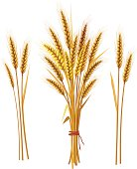
Leviticus 23:15 – 21
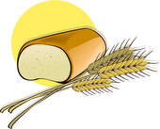

Other dates to remember during the counting of the Omer:
Hebrew Date:
Aviv/Nissan 27 Holocaust Memorial day (Yom Hashoah)
Iyar 4 Memorial Day (Yom Hazikaron)
Iyar 5 Israel Independence Day (Yom Ha'Atzmaut)
Iyar 28 Jerusalem Day (Yom Yerushalayim)
Iyar 29 Hebron (Liberation) Day (Yom Hebron)

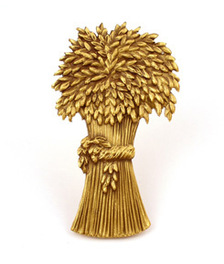
For Further information, go to:
www.returnoftheremnant.com

